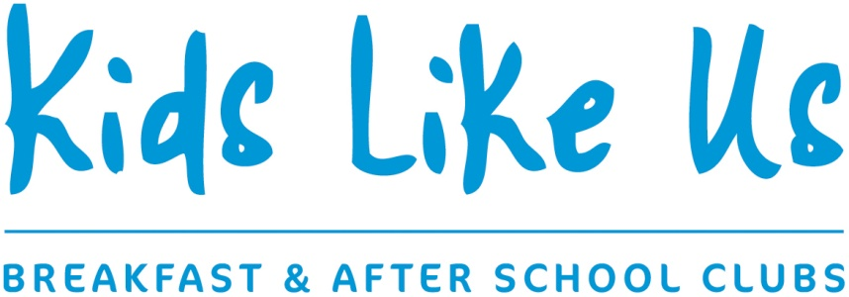

HOLIDAY CLUB BOOKING REQUEST FORM

Child’s Name:______________________________________________________________
Parent Name:______________________________Parent email: _______________________________Parent Contact Tel No_____________________________________

EASTER HOLIDAYS 2025– please tick days required
 | Monday 7th April | Tuesday 8th April | Wednesday 9th April | Thursday 10th April
Full day (8am – 6pm)
@ £42 per child per day

I understand and accept the holiday club terms and conditions (attached to email) Signed…………………………………………………………………………………………………………
** Please return a copy of this form to us at club or via email to holidayclub@kidslikeusclubs.co.uk
Places will be confirmed by email, and will only be secured after confirmation & 50% deposit is paid **

